**In Game Screen:**

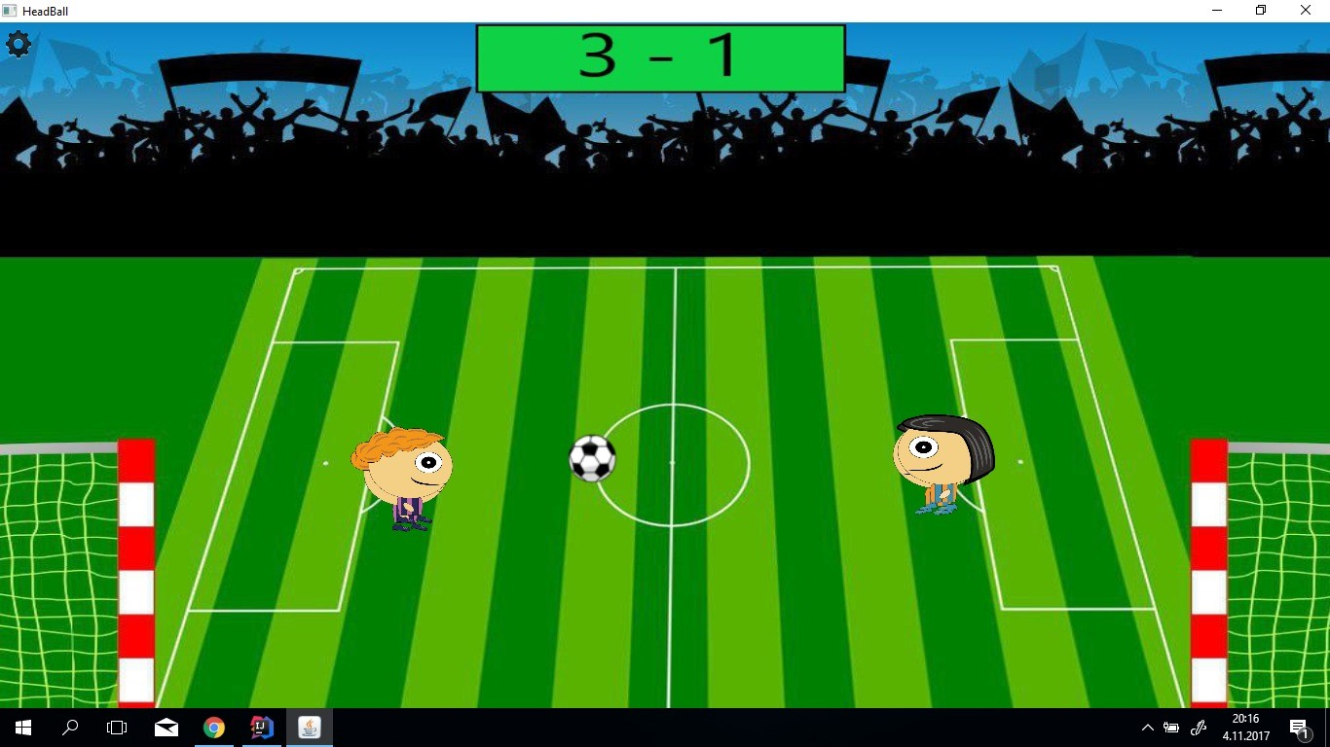

In the game, players will use their headballers to score goals. With arrow keys and w,a and d, players command their headballers to score goals.

To the moment, no powerups are implemented and frame paint rate issue is at hand, but they are soon to be implemented/fixed.

If players press escape or click the icon on the top left of the screen, options menu will pop up and bring out the pause menu.